CHAPTER THREE
SYSTEM ANALYSIS AND DESIGN
3.1 Introduction
This chapter describes how the AI-powered chatbot for university information services was analysed, designed, and planned for development. It covers the problems with the existing way information is shared at the University of Abuja, what the new system is designed to do, how it is structured, and how the different parts of it work together. The chapter also presents the diagrams, flowcharts, and tables that explain the system design. All ideas are explained in plain language so that the purpose behind each decision is easy to understand.
3.2 Research Design
The approach taken in this study combines applied research with an experimental method. The applied side addresses a real everyday problem, which is that students and staff at the University of Abuja spend a lot of time asking the same questions repeatedly and waiting for answers that could easily be automated. The experimental side involves training a machine learning model to understand those questions and match them to the right answers.
The system is built following a constructive research approach, meaning the end product is a working software system rather than a purely theoretical study. The development was done step by step, building and testing one component at a time, starting with the dataset, then the model, then the backend, and finally the frontend. This approach allowed each part to be checked and improved before the next one was added.
3.3 Analysis of the Existing System
At the University of Abuja, students, prospective applicants, staff, and visitors currently get information through the following channels:
- The official university website
- Administrative offices such as admissions, registry, bursary, and student affairs
- Social media pages and groups
- Phone calls and emails to staff
- Word of mouth between students
While these channels work to some degree, they all have significant weaknesses. Staff spend a large amount of time answering the same basic questions over and over. During busy periods such as admission season or registration week, it can take a long time to get a response. The offices are only open during working hours, so students who need information in the evening or at weekends cannot get help. Different staff members sometimes give slightly different answers to the same question. The university website contains a lot of information but it is spread across many pages and can be difficult to navigate. None of these channels offer a direct conversational way to get a quick, reliable answer. These shortcomings make it clear that a smarter, automated information system is needed.
3.4 The Proposed System
The proposed system is an AI-powered chatbot that can answer frequently asked questions about the University of Abuja through a simple web-based chat interface. A user types a question in plain everyday language and the chatbot understands what they are asking, matches it to the right topic, and returns a clear and accurate answer immediately. The system works at any time of day and does not require any human staff to be available to respond.
The chatbot was built using a machine learning model for understanding questions, a Python Flask backend for processing requests, and a Next.js frontend for the chat interface the user sees. The questions and answers are stored in a structured dataset that can be updated at any time without changing any of the system code.
3.4.1 Features of the Proposed System
The proposed chatbot system includes the following features:
- A chat interface that users can access through any web browser on a phone or computer, without needing to install anything.
- A machine learning model that reads the user's message and identifies what topic or question they are asking about.
- Predefined answers for each topic that the system retrieves and displays as soon as the intent is identified.
- Coverage of five key topic areas: admission information, Post-UTME enquiries, courses and programmes, accommodation, and clearance procedures.
- A fallback message that is shown whenever the system is not confident enough about what the user is asking, rather than giving a wrong answer.
- A layout that works properly on both desktop and mobile screens.
- A modular structure that makes it easy for the university to add new topics and answers in the future.
- Quick-question buttons that users can tap to ask common questions without typing.
3.4.2 Advantages Over the Existing System
The chatbot improves on the current approach in several clear ways. It is available 24 hours a day, seven days a week, so students can get answers even outside office hours. It gives the same consistent answer to the same question every time, removing the inconsistency that comes from different staff members responding differently. It responds immediately rather than making the user wait in a queue or for an email reply. It reduces the workload on administrative staff by handling routine questions automatically so that staff can focus on more complex issues. It is also easier for prospective applicants who may not know which office to contact, since the chatbot serves as a single point of contact for all common questions.
3.5 Requirements Analysis
Before designing or building anything, it is important to set out clearly what the system must do and how well it must perform. These requirements are grouped into two types: functional requirements, which describe what the system does, and non-functional requirements, which describe how well it does it.
3.5.1 Functional Requirements

Table 3.1: Functional Requirements of the Chatbot System
No. | Ref. | Requirement | Priority
1 | FR1 | The system shall accept text-based questions from users through a web-based chat interface. | High
2 | FR2 | The system shall classify each user message into one of the predefined intent categories using a trained machine learning model. | High
3 | FR3 | The system shall retrieve and display an appropriate response from the dataset based on the predicted intent. | High
4 | FR4 | The system shall display all messages and responses in a conversational chat format. | High
5 | FR5 | The system shall return a polite error message if the user submits an empty or invalid input. | High
6 | FR6 | The system shall return a fallback response when the model's confidence score falls below the defined threshold. | Medium
7 | FR7 | The system shall send and receive data between the frontend and backend through a REST API endpoint. | High
8 | FR8 | The system shall allow new intents and responses to be added simply by editing the dataset file, without changing any code. | Medium

3.5.2 Non-Functional Requirements

Table 3.2: Non-Functional Requirements of the Chatbot System
No. | Ref. | Category | Requirement
1 | NFR1 | Usability | The interface must be simple and clear enough for any student or staff member to use without any prior training.
2 | NFR2 | Reliability | The system must respond correctly and consistently during normal use without crashing or producing incorrect results.
3 | NFR3 | Performance | The chatbot must return a response within three seconds under normal network conditions.
4 | NFR4 | Scalability | The design must make it easy to add new topics and responses in the future without redesigning the system.
5 | NFR5 | Maintainability | The code must be structured clearly so that any part of it can be updated or fixed without breaking other parts.
6 | NFR6 | Security | The API must check and clean all user inputs before processing them, and must not expose any internal system details.

3.5.3 Hardware and Software Requirements
The system is designed to run on a standard personal computer or laptop. The minimum hardware needed is a computer with at least an Intel Core i3 processor or equivalent, at least 4 GB of RAM, at least 10 GB of free storage space, and a working internet connection. The software required to run the system includes Python 3.10 or higher, Node.js 18 or higher, and a modern web browser. A code editor such as Visual Studio Code is recommended for anyone who wants to update or maintain the system.
3.6 System Architecture
The chatbot system is organised into three separate layers, each responsible for a different part of the work. This separation means that if one part needs to be updated or replaced, it can be done without disturbing the others. Figure 3.1 below shows how the three layers connect and how information flows between them.

Figure 3.1: Three-Tier System Architecture
LAYER 1 — PRESENTATION LAYER (Frontend)
Next.js + React + TypeScript + Tailwind CSS
Chat interface | User input box | Message display | Quick-question buttons
↓
LAYER 2 — APPLICATION LAYER (Backend)
Python Flask + Flask-CORS
Receives user message | Cleans and vectorises input | Calls ML model | Returns response
↓
LAYER 3 — MACHINE LEARNING AND DATA LAYER
scikit-learn (TF-IDF + Naive Bayes) | intents.json dataset
Predicts intent | Retrieves matching response | Checks confidence threshold

3.6.1 Presentation Layer
The presentation layer is the chat interface that the user sees and interacts with in their browser. It is built using Next.js, React, TypeScript, and Tailwind CSS. When a user types a question and presses send, the frontend collects the message and sends it to the backend through an HTTP request. When the backend responds, the frontend displays the answer in the chat window. The layout adjusts automatically to fit different screen sizes, so it works properly on both phones and computers.
3.6.2 Application Layer
The application layer is the backend of the system, built using Flask. It acts as the bridge between the chat interface and the machine learning model. When a message arrives from the frontend, the backend cleans and transforms it into the numerical format the model needs, runs the prediction, retrieves the correct response from the dataset, and sends it back to the frontend in a structured format. It also handles any errors, such as empty inputs or low-confidence predictions, and returns the appropriate fallback message in those cases.
3.6.3 Machine Learning and Data Layer
This layer contains the trained Naive Bayes model, the TF-IDF vectoriser used to convert text into numbers, and the intents.json dataset which holds all the question patterns and answers. When the backend sends a cleaned user message to this layer, the vectoriser converts it and the model predicts which intent category it belongs to. If the confidence score is high enough, the matching response is retrieved. If not, the fallback message is returned. Each of these components is stored separately so that the dataset can be updated or the model retrained without affecting the rest of the system.
3.7 Dataset Development
3.7.1 Dataset Structure
The dataset that powers the chatbot is stored as a JSON file called intents.json. It is made up of a list of intent objects, and each one has three parts. The tag is a short unique name that identifies the topic, such as "admission" or "accommodation". The patterns section contains a list of different ways a user might ask about that topic in everyday language. The responses section contains one or more possible answers that the system will choose from when that intent is detected. A simplified example of the structure is shown below.

{
"intents": [
{
"tag": "admission_requirements",
"patterns": [
"What are the admission requirements?",
"How do I apply to the University of Abuja?"
],
"responses": [
"For undergraduate admission, you need five O-Level credits..."
]
}
]
}

3.7.2 Intent Categories
The dataset covers five main topic areas, which were selected based on the questions most commonly asked by students and prospective applicants at the University of Abuja. These are admission information, Post-UTME enquiries, courses and programmes, accommodation, and clearance procedures. In addition, the dataset includes conversational intents, greeting, gratitude, farewell, and small talk, that allow the chatbot to respond naturally to opening messages, thanks, goodbyes, and light banter about itself, consistent with the Human-Computer Interaction principles discussed in Section 2.3.1, as well as a fallback intent for questions the system cannot confidently match. Each topic has multiple patterns written in different ways to help the model recognise the same question even when it is phrased differently.
3.7.3 Dataset Design Principles
The dataset was built with five principles in mind. Domain relevance means every question and answer in the dataset is specific to the University of Abuja and its actual processes. Lexical variation means each intent has many different pattern phrasings so the model can recognise the same question asked in different ways. Clarity of responses means every answer is written in plain, accurate language that a student can act on immediately. Extensibility means new topics and answers can be added by editing the JSON file without touching any code. Generalisability means the patterns are written to cover common ways of asking rather than highly specific or unusual ones.
3.8 Tools and Technologies Used
3.8.1 Software Tools
The following software tools were used to build the chatbot system:
- Python 3.10 was used for all backend development and machine learning work. It was chosen because it is the most widely used language in machine learning, has excellent library support, and runs on all operating systems.
- Flask 2.x with Flask-CORS was used as the web framework for the backend API. It is lightweight, easy to set up, and works well with Python machine learning libraries.
- scikit-learn was used for TF-IDF vectorisation and Multinomial Naive Bayes classification. It provides reliable, well-tested implementations of both within a simple and consistent interface.
- pickle was used to save the trained model and vectoriser to disk so they can be loaded quickly each time the application starts, without retraining.
- Next.js and React were used to build the frontend chat interface. They produce fast, responsive pages that work on both desktop and mobile without requiring any software installation.
- TypeScript was used on the frontend for more reliable and structured code development.
- Tailwind CSS was used for all interface styling. It made it easy to produce a clean, consistent layout that adjusts to different screen sizes.
- JSON was used as the format for storing the intent dataset because it is simple, human-readable, and easy to update.
- Visual Studio Code was used as the development environment for writing and testing all code.
- Git was used for version control throughout the project, keeping track of all changes made during development.
3.8.2 Human Tools and Data Collection
In addition to the software tools, a structured data collection process was carried out to ensure that the chatbot's dataset reflects real questions that actual students ask. A Google Form was designed and distributed to students at the University of Abuja. The form presented five topic areas, matching the five intent categories in the system's scope, and asked respondents to write down the questions they would naturally ask about each topic in their own words. This approach made it possible to collect a wide variety of natural phrasings that real students use, rather than relying on made-up examples.
The responses collected from the Google Form were reviewed, cleaned, and used to build the patterns section of the intents.json dataset. This means the chatbot was trained on real student language rather than guessed questions, which significantly improves how well it understands the way users actually phrase their queries. Table 3.3 below shows the five intent categories and the types of questions that were collected under each one.

Table 3.3: Intent Categories and Sample Questions Collected via Google Form
No. | Intent Category | Sample Questions Asked in the Form
1 | Admission Information | What are the admission requirements? How do I apply to the University of Abuja? What is the cut-off mark?
2 | Post-UTME Enquiries | When is the Post-UTME screening? How do I register for Post-UTME? What documents do I need for Post-UTME?
3 | Courses and Programmes | What courses are available at University of Abuja? Which faculty offers Computer Science?
4 | Accommodation | Is there a hostel on campus? How do I apply for accommodation? How much is the hostel fee?
5 | Clearance Procedures | How do I do my clearance? What do I need for departmental clearance? When does clearance start?

3.9 Machine Learning Model Design
3.9.1 Problem Formulation
The task the chatbot needs to perform is a text classification problem. When a user sends a message, the system needs to read it and decide which of the predefined intent categories it belongs to. The input is the user's typed message and the output is one of the intent tags such as "admission", "accommodation", or "clearance". Once the right category is identified, the matching answer is retrieved from the dataset.
3.9.2 Model Selection
The Multinomial Naive Bayes algorithm was chosen for this task. It works well with text data represented as word frequency counts, which is exactly what TF-IDF vectorisation produces. It is fast to train, performs reliably even when the training dataset is small to medium in size, and is straightforward to understand and explain. These qualities make it a practical and well-suited choice for a domain-specific chatbot where the number of intent categories is limited and the vocabulary is fairly consistent.
3.9.3 Training Process
The training process works as follows. The intents.json file is loaded and the question patterns are extracted as the training inputs, with their corresponding intent tags as the labels. The TF-IDF vectoriser is fitted on all the patterns and converts each one into a numerical vector. The Naive Bayes model is then trained on these vectors. Once training is complete, both the fitted vectoriser and the trained model are saved to disk so they can be loaded quickly each time the web application starts.
3.9.4 Prediction Process
When a user sends a message, the backend receives it and passes it through the same TF-IDF vectoriser used during training. The resulting vector is fed to the Naive Bayes model, which predicts the most likely intent category and produces a confidence score. If the confidence score meets or exceeds the defined threshold, the system retrieves one of the responses for that intent and sends it back to the user. If the confidence score is too low, the system instead returns a fallback response that politely tells the user it was not able to understand the question and suggests they rephrase it.
3.10 System Design Flowchart
Figure 3.2 below shows the overall flow of the system from the moment a user sends a message to the moment a response is displayed. It covers the full path of a request through all three layers of the system.

Figure 3.2: System Flowchart
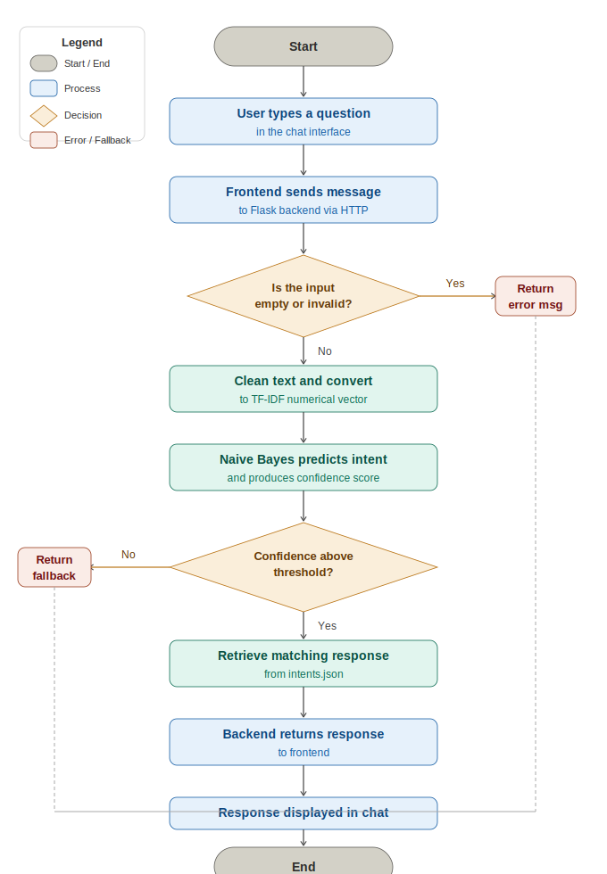
3.11 Use Case Diagram
Figure 3.3 below shows the use case diagram for the chatbot system. It shows who uses the system and what actions they can perform.

Figure 3.3: Use Case Diagram
ACTOR: User (Student, Prospective Applicant, or Staff Member)

USE CASES:
UC1 — Type and send a question through the chat interface
UC2 — Receive an answer about admission requirements
UC3 — Receive an answer about Post-UTME
UC4 — Receive an answer about available courses and programmes
UC5 — Receive an answer about accommodation on campus
UC6 — Receive an answer about clearance procedures
UC7 — Receive a fallback message when the question is not understood
UC8 — Use quick-question buttons to ask common questions without typing

ACTOR: System (Backend Engine)
Processes user message, predicts intent, retrieves and returns correct response

3.12 Entity Relationship Diagram
Although the system does not store user conversations in a database, it works with several important data entities internally. Figure 3.4 below shows how these entities relate to one another.

Figure 3.4: Entity Relationship Diagram
USER MESSAGE
raw_text (string typed by the user)
|
| processed by
v
PREPROCESSED INPUT
cleaned_text, tfidf_vector
|
| fed into
v
INTENT PREDICTION
predicted_tag, confidence_score
|
| matched against
v
INTENT OBJECT (from intents.json)
tag, patterns[ ], responses[ ]
|
| produces
v
CHATBOT RESPONSE
selected_response (displayed to user)

3.13 Implementation Procedure
The system was built following a structured sequence of steps to make sure each part was working correctly before the next one was added. The steps were as follows:
- Environment setup: creating the Python virtual environment and installing all required libraries.
- Data collection: distributing the Google Form to students and collecting their natural language questions across the five intent categories.
- Dataset creation: reviewing the collected responses, cleaning them, and building the intents.json file with patterns and answers for each intent.
- Model training: running the TF-IDF vectorisation, training the Naive Bayes classifier, and saving the model and vectoriser to disk.
- Backend development: building the Flask API with the /chat endpoint that handles incoming messages and returns responses.
- Frontend development: building the Next.js chat interface that users interact with.
- System integration: connecting the frontend to the backend through HTTP requests and testing that messages and responses flow correctly between them.
- Testing and refinement: submitting test questions across all five intent categories, checking the responses, and making improvements where needed.
3.14 System Evaluation Approach
The system will be evaluated in two ways. The first is functional testing, where a set of test questions is submitted across all five intent categories to check that the system returns the correct and expected responses in each case. The second is qualitative assessment, where the clarity, accuracy, and relevance of the chatbot's responses are examined to determine whether they would genuinely help a student who asked that question. Both forms of evaluation are described in detail in the following chapter.

